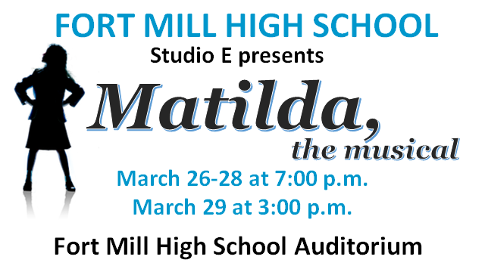_

Check, along with this section of the form to be placed in envelope with *Matilda*, Playbill Shout-out on the outside, and placed in the lockbox in Ms. Williams’ room.

**Due date: February 28, 2020**

Parent’s Name: ______________________________________________

Number of Playbill Shout-outs and size: ___ 1/4 pg $25; ___ 1/2 pg $40; ____full page $75

Amount Enclosed: __________ Check #: ________Cash: (exact change)________

Email:__________________________________ Contact #: ______________________

Received by: ______________ (Booster treasurer/president’s initials)

Shout-Out email received: ____________________ (Booster initials)

Shout-out should include cast(s) name, message and who it is from. **The smallest font used in the playbill will be 6.** Font will be adjusted so message fits nicely in the ad space. The more words, the smaller the font etc.

Please email shout-out(s) message(s) to fmhs.performingarts.sc@gmail.com and copy Diane at [dulindiane@fbcfm.com](mailto:dulindiane@fbcfm.com) by **February 28.**

1/4 page $25; 1/2 page $40; full page $75

All proceeds go to the FMHS Performing Arts Boosters (Choral Boosters)

to support the Theatre Department.

***Please make check payable to FMHS Choral Boosters and***

***note Playbill Cast Shout-Out in memo line.***

----------------------------------------------------------------------------------------------------------------------------------------------------------------------

**Would you like to recognize your senior in their last playbill at FMHS?**

**Would you like to recognize your cast member(s)?**

**How about giving him/her a shout-out in the playbill? If so, complete a Playbill Cast Shout-out or two…**