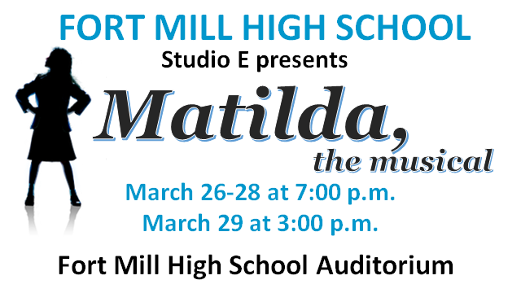

**Organization purchasing ad keeps top portion of this form. Cast member to turn in this portion along with check. Place in envelope labeled *Matilda* Playbill Spotlight & place in the lockbox in Ms. Williams’ room by February 28, 2020**

Organization’s Name: ______________________________________________

**Playbill Spotlight Purchased:** ____business card $45; ____quarter page $75;

____ half page $100; ____ full page $175

Amount Paid: _____________ Check #: ______________

Sold By: ______________________ Contact #: ________________Email:__________________________

Received by: _________________ (Booster treasurer/president’s initials)

Playbill info received: ____________(Booster initials)

--------------------------------------------------------------------------------------------------------------------------------------------------------------------------

**PRICES**

**$45 business card – no art**

**$75 quarter page**

**$100 half page**

**$175 full page**

All proceeds go to the FMHS Performing Arts Boosters (Choral Boosters) to support the Theatre Program at Fort Mill High School.

Your donations are tax deductible. The FMHS Performing Arts Boosters’ Tax ID is: 30-0212686

Please email artwork/information to [fmhs.performingarts.sc@gmail.com](mailto:fmhs.performingarts.sc@gmail.com) and copy Diane at [dulindiane@hotmail.com](mailto:dulindiane@hotmail.com) by **February 28, 2020**

***Please make check payable to FMHS Choral Boosters & note Playbill Spotlight in memo line & give to cast member/parent.***

*Reach 1000s of theatre goers. Playbills are often saved as keepsakes.*

**Thank you for supporting Fort Mill High School Theatre**

**with a Playbill Spotlight**